**Image classification with SVM - Support Vector machine**

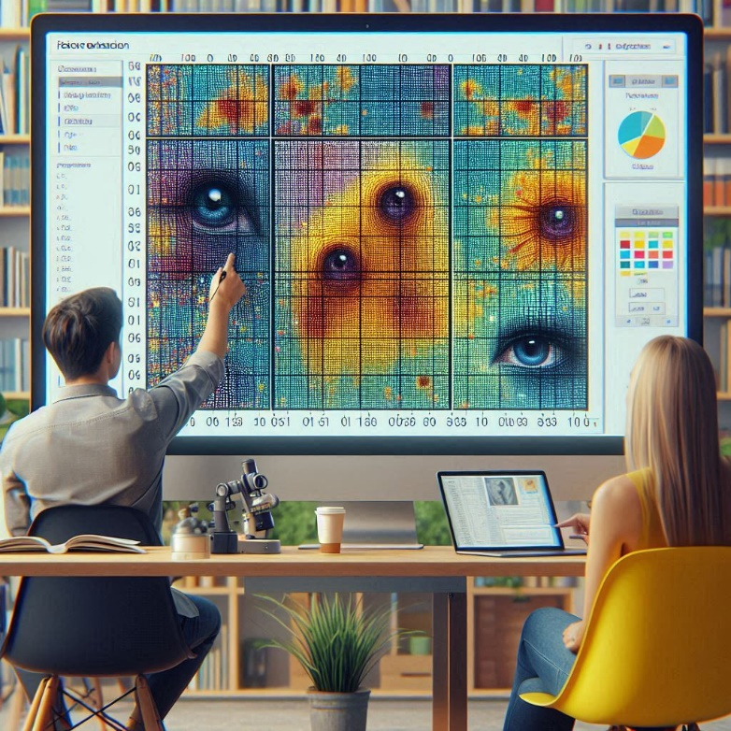Image classification using Support Vector Machines (SVMs) involves a few steps:

**Feature Extraction:** When a computer processes an image, it perceives it as a two-dimensional array of pixels. The size of the array corresponds to the resolution of the image. The values in the array can range from 0 to 255, which indicates the intensity of the pixel at each point. In order to classify an image using an SVM, we first need to extract features from the image. These features can be the color values of the pixels, edge detection, or even the textures present in the image.

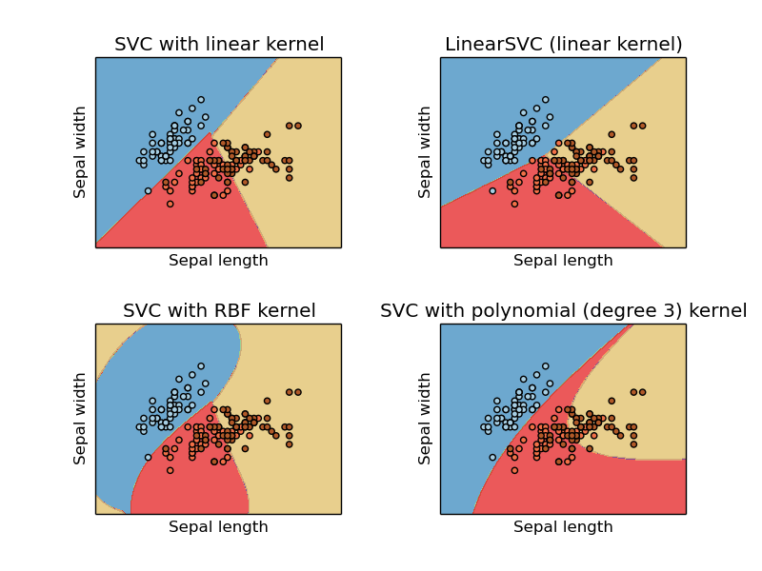**SVM Algorithm:** Once the features are extracted, we can use them as input for the SVM algorithm. The SVM algorithm works by finding the hyperplane that separates the different classes in the feature space. The key idea behind SVMs is to find the hyperplane that maximizes the margin, which is the distance between the closest points of the different classes.

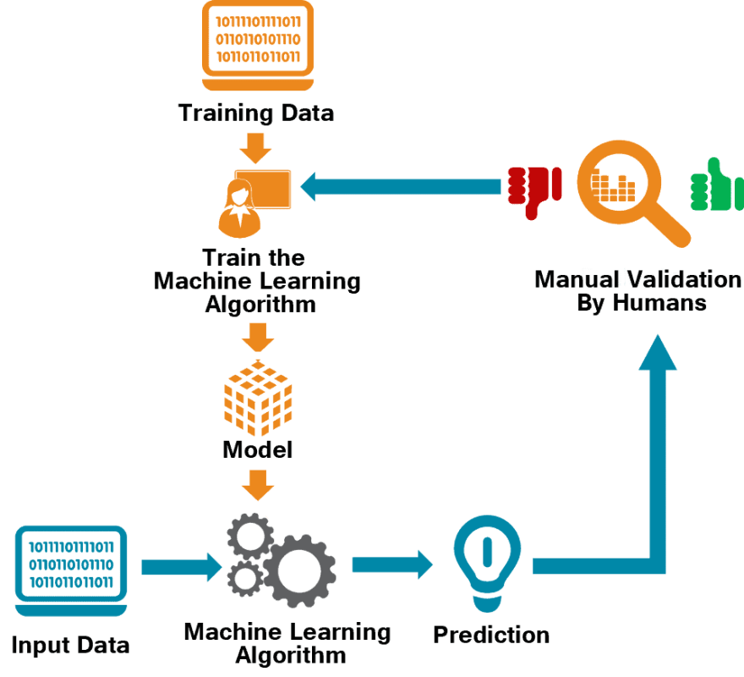In machine learning where the model is trained by input data and expected output data.  
To create such a model, it is necessary to go through the following phases:

* Import required libraries
* Load the image and convert it to a dataframe.
* separate input features and targets.
* Split train and test value.
* Build and train the model
* Model evaluation.
* Prediction

**Reflective Journal on Image Classification using SVM with CIFAR-10 Dataset**

**Reflection on Learning**

**Understanding of SVM and its Application in Image Classification**

The Support Vector Machine (SVM) is a powerful supervised machine learning algorithm used for classification or regression problems. It works by finding the hyperplane that best divides the dataset into classes. In the context of image classification, SVMs can be very effective, especially when used with a good set of image features.

**Data Preparation, Model Training, and Evaluation**

The data preparation involved loading the CIFAR-10 dataset, converting the images to grayscale, and flattening them. The model training involved training an SVM classifier on the training set. The model evaluation involved making predictions on the testing set and evaluating the model’s performance using accuracy.

**Loading the CIFAR-10 dataset:** This step involves using the tensorflow library to load the CIFAR-10 dataset. This dataset is widely used for image classification tasks.

**Visualizing some images from the dataset:** This helps in understanding the kind of images we are dealing with. It’s done using matplotlib library.

**Converting the images to grayscale and flattening them:** This is a part of preprocessing the images to make them suitable for the SVM classifier.

**Splitting the dataset into training and testing sets:** This is a common practice in machine learning to evaluate the performance of the model.

**Model Training:**

**Understanding the concept of Support Vector Machine (SVM**): SVM is a supervised machine learning algorithm which can be used for both classification or regression challenges. In this case, it’s used for multi-class classification.

**Training an SVM classifier using the training set:** This involves fitting the model to the training data using the scikit-learn library.

**Model Evaluation:**

**Making predictions on the testing set:** Once the model is trained, it can be used to make predictions on unseen data.

**Evaluating the model’s performance using accuracy:** Accuracy is a common metric for classification tasks. It’s the ratio of correct predictions to the total number of predictions.

**Challenges and Insights**

Despite its small size and relatively low resolution, CIFAR-10 remains a challenging dataset for machine learning models due to the variety of object classes, background clutter, and variations in object appearance and orientation within each class.

The CIFAR-10 dataset consists of 60000 32x32 colour images in 10 classes, with 6000 images per class. There are 50000 training images and 10000 test images.

The dataset is divided into five training batches and one test batch, each with 10000 images. The test batch contains exactly 1000 randomly-selected images from each class. The training batches contain the remaining images in random order, but some training batches may contain more images from one class than another. Between them, the training batches contain exactly 5000 images from each class.

Above are the classes in the dataset, as well as 10 random images from each:

**The CIFAR-100 dataset**

This dataset is just like the CIFAR-10, except it has 100 classes containing 600 images each. There are 500 training images and 100 testing images per class. The 100 classes in the CIFAR-100 are grouped into 20 superclasses. Each image comes with a "fine" label (the class to which it belongs) and a "coarse" label (the superclass to which it belongs).

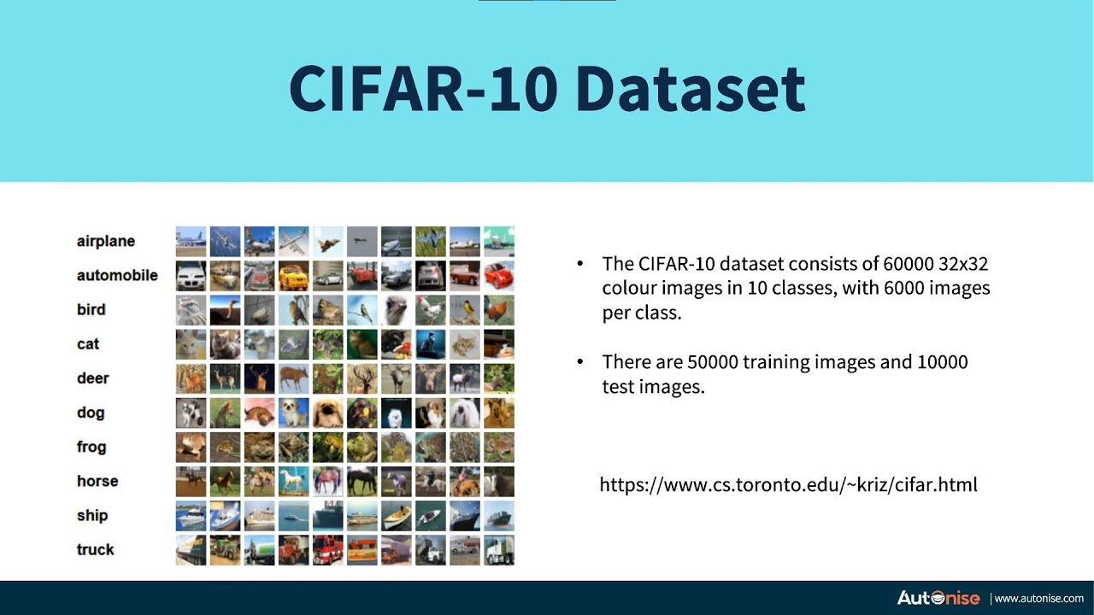Here is the list of classes in the CIFAR-100:

|  |  |
| --- | --- |
| **Superclass** | **Classes** |
| aquatic mammals | beaver, dolphin, otter, seal, whale |
| fish | aquarium fish, flatfish, ray, shark, trout |
| flowers | orchids, poppies, roses, sunflowers, tulips |
| food containers | bottles, bowls, cans, cups, plates |
| fruit and vegetables | apples, mushrooms, oranges, pears, sweet peppers |
| household electrical devices | clock, computer keyboard, lamp, telephone, television |
| household furniture | bed, chair, couch, table, wardrobe |
| insects | bee, beetle, butterfly, caterpillar, cockroach |
| large carnivores | bear, leopard, lion, tiger, wolf |
| large man-made outdoor things | bridge, castle, house, road, skyscraper |
| large natural outdoor scenes | cloud, forest, mountain, plain, sea |
| large omnivores and herbivores | camel, cattle, chimpanzee, elephant, kangaroo |
| medium-sized mammals | fox, porcupine, possum, raccoon, skunk |
| non-insect invertebrates | crab, lobster, snail, spider, worm |
| people | baby, boy, girl, man, woman |
| reptiles | crocodile, dinosaur, lizard, snake, turtle |
| small mammals | hamster, mouse, rabbit, shrew, squirrel |
| trees | maple, oak, palm, pine, willow |
| vehicles 1 | bicycle, bus, motorcycle, pickup truck, train |
| vehicles 2 | lawn-mower, rocket, streetcar, tank, tractor |

**Indices into the original 80 million tiny images dataset**

This maps CIFAR-100 images to images in the 80 million tiny images dataset. Sivan Writes:

The file has 60000 rows, each row contains a single index into the tiny db,

where the first image in the tiny db is indexed "1". "0" stands for an image that is not from the tiny db.

The first 50000 lines correspond to the training set, and the last 10000 lines correspond

to the test set.

**Difference between CIFAR 10 and custom dataset**

**1. Introduction**

In the realm of machine learning, the choice of dataset plays a crucial role in model development and performance. This discussion compares the advantages and disadvantages of using a well-known, pre-existing dataset like CIFAR with the approach of constructing a custom dataset tailored to specific needs

**2. CIFAR Dataset Utilization**

**Advantages:**

**Preprocessed Data**: The CIFAR-10 and CIFAR-100 datasets are already preprocessed and formatted, facilitating a straightforward pipeline for training machine learning models. This eliminates the need for extensive data cleaning and preparation efforts.

**Standardization:** These datasets are widely recognized benchmarks in the machine learning community. Utilizing them allows researchers to compare their model's performance against a plethora of existing results, ensuring consistency in performance evaluation.

**Accessibility:** Integrated into popular machine learning libraries such as TensorFlow and PyTorch, CIFAR datasets can be effortlessly loaded and used, streamlining the workflow for researchers.

**Balanced Data:** The datasets are balanced with an equal distribution of samples across classes, which is essential for training unbiased models.

**Disadvantages:**

**Limited Scope:** CIFAR datasets consist of fixed classes and low-resolution images (32x32 pixels), which may not encompass the complexity or specificity required for certain advanced applications.

**Overfitting Risk:** Due to their extensive use, there is a potential risk of developing models that are overfitted to these benchmarks rather than being generalized to novel, unseen data.

**Lack of Specificity:** For domain-specific applications such as medical imaging or autonomous driving, CIFAR datasets may not contain relevant categories or features, limiting their applicability.

3**. Building a Custom Dataset**

**Advantages:**

**Customization:** Custom datasets allow for tailoring data collection to specific applications, encompassing relevant categories, higher image resolutions, and varied data types, thereby improving model applicability.

**Data Relevance:** Ensuring the dataset is highly relevant to the specific problem enhances the model's performance and applicability in real-world scenarios.

**Variety and Complexity:** Custom datasets can incorporate a variety of sources and complexities that are absent in standard datasets like CIFAR, offering a richer training environment and potentially improving model robustness.

**Disadvantages:**

Time-Consuming: The process of collecting, labeling, and preprocessing a custom dataset is resource-intensive and time-consuming, requiring significant effort and expertise.

**Quality Control:** Maintaining data quality and consistency across a large dataset is challenging. Inaccurate or inconsistent data can adversely affect model performance.

**Balancing Data:** Ensuring a balanced representation of all classes within a custom dataset is often difficult, especially for rare categories, leading to potential biases in model training.

**Validation and Testing:** Without established benchmarks, validating and comparing the performance of models can be more complex, necessitating the creation of robust validation strategies.

**4. Key Considerations for Custom Dataset Development**

**Data Collection**: Consideration must be given to the sources of data, ethical implications, and privacy concerns. Diverse sources can enrich the dataset but require meticulous handling to ensure ethical compliance.

**Labeling:** Accurate and consistent labeling is paramount. This might involve manual annotation or automated processes, with tools such as crowdsourcing platforms (e.g., Amazon Mechanical Turk) being useful for large-scale annotations.

**Preprocessing:** Custom datasets often require extensive preprocessing, including resizing, normalizing, and augmenting data to enhance variability and robustness in model training.

**Data Split:** Properly splitting the dataset into training, validation, and test sets is crucial for unbiased model evaluation and to prevent overfitting.

5**. Conclusion**

The choice between using a pre-existing dataset like CIFAR and building a custom dataset hinges on the specific requirements of the project. CIFAR offers convenience, standardization, and accessibility, making it ideal for benchmarking and initial model development. However, for domain-specific applications requiring higher specificity, relevance, and complexity, constructing a custom dataset, despite its challenges, may provide more significant benefits and lead to more effective and applicable machine learning solutions.

Citations:

[Image classification using Support Vector Machine (SVM) in Python - GeeksforGeeks](https://www.geeksforgeeks.org/image-classification-using-support-vector-machine-svm-in-python/)

[Support Vector Machines for Image Classification and Detection Using OpenCV - MachineLearningMastery.com](https://machinelearningmastery.com/support-vector-machines-for-image-classification-and-detection-using-opencv/)

[CIFAR10 DataSet in Keras (Tensorflow) for Object Recognition - GeeksforGeeks](https://www.geeksforgeeks.org/cifar10-dataset-in-keras-tensorflow-for-object-recognition/)

[CIFAR-10 and CIFAR-100 datasets (toronto.edu)](https://www.cs.toronto.edu/~kriz/cifar.html)

[Understanding the CIFAR 10 Dataset (youtube.com)](https://www.youtube.com/watch?v=PxFAKtMLu8M)